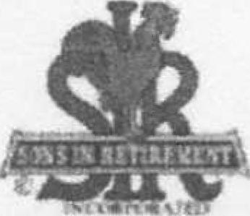
Las Trampas Branch 116
Luncheon Meeting Agenda
February 15, 2016
11:40 AM
- Call to Order — Big SIR
- Pledge of Allegiance
- Invocation — Doug Aalders
- Sunshine Report - Matt Arena (Note Matt unable to attend. Defer to March lunch meeting)
- Introduce Head Table
  - Chaplin - Doug Aalders
  - Acting Little SIR - Bob Donohue
  - Speaker: Dr. Joel White
- Introduce Guests & Visitors
- Guests:
- Paul Bradley – Guest of Ron Armijo
- Ed Domanski – Guest of Dennis Perry
- Bob Pinzus – Guest of Norm Schoenfeld
- Rich Conti – Guest of Bob Donohue
- Visitors – Don Rushton and Gary Felix (soon to be members)
- Big SIR comments
  - Mention Trampas Topics. Also mention SlRinc.org, containing a newsletter of additional regional activities
  - Thank and congratulate SIR Ben Smith on the January Crow Canyon Brunch
  - Carmel Golf Outing, May 17th & 18th entry form in February's Newsletter
  - Parking – Next door unavailable due to demolition. Feb 16 – Jun 1.
  - Park only in designated areas. Quail Court across street – Down Below
- Acting Little SIR Comments?
11:50 AM Lunch
- Anyone with walker, cane or disability who may need some assistance
- Head Table, Guests and Committee Chairmen who will be reporting
- Announce Rows 3, 4, 1, 2
12:15 PM
- Story Teller — Fred Schafer
- Install New Members – Peter Ciarlo
- Committee Reports
- Raffle Drawing
12:45 PM
1. Little SIR:
a. Introduce Dr. Joel White, our Speaker for January
1:30 PM Adjourn

