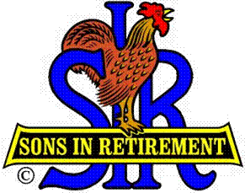**Las Trampas Branch 116**

**BEC Meeting Agenda**

**April 15, 2019, 9:30 AM**

***The Mission of SIR is to improve the lives of our members through fun activities and events – while making friends for life.***

**09:15** Coffee Available

**09:30**  Call to order; Secretary confirm a quorum

**09:31** Secretary – Fred Schafer – Approval of March 18 minutes

**09:33** Treasurer – Jim Nickels – Treasurers Report; Annual dues Update

**09:37**  Standing Reports

1. Attendance – Jim Flessner – Attendance, Guests, Visitors
2. Membership – Phil Goff – New Members to be inducted,
3. Spring Fling – Alan Fitzgerald
4. Activities Chair – Fred Wachowicz/ Mike Ward

**09:45** Big SIR Report – by Jerry Hicks

1. RAMP and Nom Committee training, May 3, Rossmoor
2. Sirinc Navigation Video
3. A’s Giants BB game at Oakland; Sunday, Aug 25

**09:50** Little SIR Report – Michael Barrington

1. Speaker:  J.D. Bergeron: International Bird  Rescue

**10:02**  Old Business

1. E-payments with Venmo – Jim Flessner and Jim Nickels

**10:07**  New Business:

1. Branch Assessment and Best Branch Award 2018 -

**10:15** Other Discussion

**10:20** Adjourn; Next BEC Meeting, June 17, 0930