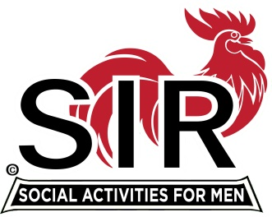**Las Trampas Branch 116**

**Luncheon Meeting Agenda**

**October 21, 2019, 11:30 AM**

**09:30** BEC Meeting

**10:30** Social Hour

Greeters – Henry Haugse and Don Marini

Raffle – Bob Huck and David Ferm

New Member Orientation – Sam Beret

**11:25**  Five Minute Call

**11:30** Call to order; Opening Remarks – Big SIR

Pledge of Allegiance – Allan Chasnoff

Chaplain – Jerry Kaplan

Sunshine Report – Matt Arena

**11:38** Story Teller – Mac McLoughlin

**11:42** Introduce Speaker – Nan Su – Chinese Culture

Guests – Recruitment - Don Schroeder - **Tim Martin** (Darrell Dummett); **Mike Chimenti** (Roger Craig); **Alan Mark** (Bob Donohue); **Jerry Coil** (David Williams); **Neal Pereira** (Alan Fitzgerald)

New Member Introduction – Jerry – **Tony DeGrassi** (Garrett Girvan); **John Mulgrew** (David Harris); **Salem Attiga** (Don Schroeder)

Recognize Greeters – Jerry (Henry Haugse and Don Marini)

Awards – Urs Christen – 25 year Membership

**11:45** Salad Served

**11:52**  RAMP Department Heads Reports

**12:00** Lunch

**12:35** Activity Committee Reports

**12:43**  Speaker – Nan Su – Chinese Culture – Speaker Committee

**13:20** Speaker Thank You

**13:23** Raffle Drawing - Bob Huck and David Ferm

Birthday Drawing – Little SIR

**13:27** Sing Happy Birthday – Music Men

Sing God Bless America

**13:30** Adjourn; Next Meeting, November 18, 2019