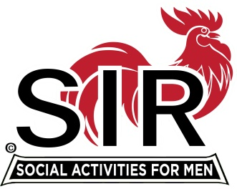**Las Trampas Branch 116**

**Special BEC Meeting Agenda**

**April 27, 2021, 8:30 AM**

***The Mission of SIR is to enhance the lives of our members through fun activities, events and luncheons – while making friends for life.***

**8:30 am** Call to order; Secretary confirm a quorum

**8:35** Big SIR Report – Sam Beret

1. State SIR Directives
2. Directors’ Liability Coverage
3. Discussion: Next Steps for Branch Activities

a- outdoor activities that are currently open

b- for “indoor” activities that may be opened in the coming months

**9:00**  Branch website - Neil Schmidt, Phil Goff

**9:30**  Adjourn; Next BEC Meeting, May 17, 2021

Join Zoom Meeting Weblink

<https://us02web.zoom.us/j/85332344422>

Meeting ID: 853 3234 4422

Passcode: 612956

Dial by home phone: (669) 900-9128