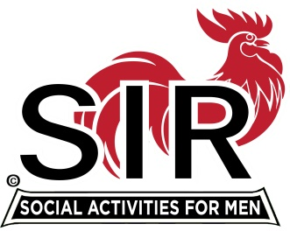**Las Trampas Branch 116**

**BEC Meeting Agenda**

**July 19, 2021, 9:30 AM at Boundary Oak**

***The Mission of SIR is to enhance the lives of our members through fun activities, events and luncheons – while making friends for life.***

**9:30 am** Call to order; Secretary confirm a quorum

**9:35** Secretary –Paul Ramacciotti – Approval of June 21, 2021 BEC meeting minutes

**9:40** Treasurer –/Alan Fitzgerald – Report

**9:45**  Standing Reports

1. Membership – Phil Goff
2. RAMP Department Head Reports:

* Recruitment
* Activity Coordinator
* Member relations
* Publicity

1. Covid Compliance [Kevin Donahue]

**10:00** Big SIR Report – Sam Beret

1. July 19 monthly meeting agenda

2. Boundary Oak Lunch Contract

3. Nominating Committee - August 16, Election of Officers and Directors

**10:15** Little SIR Report - Fred Wachowicz

1. Speaker

2. Birthday Boys

3. Diversity Team Report

**10:25**  Old Business

New Business

**10:30** Adjourn; Next BEC Meeting, August 16, 2021

New Members – 2021:

Dave Havlik: his sponsor - Fred Schafer.

Dick Frankel: his sponsor - Paul Freitas

Bruce Bressler: his sponsor - Don Schroeder

Guests for July 19, 2021:

Terry Sherman's guest is Bill Foulds

Mike Yale's guest is Gary Diefenbacher

