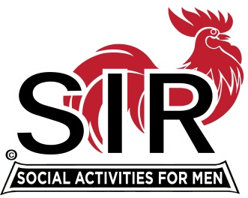
Las Trampas Branch 116
BEC Meeting Agenda
January 18, 2021, 8:30 AM
The Mission of SIR is to enhance the lives of our members through fun activities, events and luncheons – while making friends for life.

8:30 Call to order; Secretary confirm a quorum
8:35 Secretary – Paul Ramacciotti – Approval of December 2020 minutes
8:40 Treasurer –/Alan Fitzgerald – Report
8:45 Audit report 2020: Ron Armijo
Approve Audit Report
9:00 Standing Reports
- Membership – Phil Goff
- RAMP Department Head Reports:
- Recruitment
- Activity Coordinator
- Member relations
- Publicity
9:10 Big SIR Report – Sam Beret
- Branch goals 2021
- State SIR “Town Hall” Meeting
- State SIR Leadership Summit [Training]
9:30 Little SIR Report - Fred Wachowicz
1. Speaker:
2- Birthday Boys
3- Diversity Team Report
9:40 Virtual Lunch Zoom Process - Neil Schmidt
9:45 Old Business
- TBA
New Business:
- Approve Branch activities subject to: 1- Health Directives from CA and Contra Costa County, 2- State SIR Directives
- Minutes should reflect that all in-person branch activities are currently suspended until we get a clear mandate from CA, Contra Costa County and State SIR to reopen those activities
- Confirm Nominating Committee
9:50 Other Discussion

10:00 Adjourn; Next BEC Meeting, February 15, 2021

