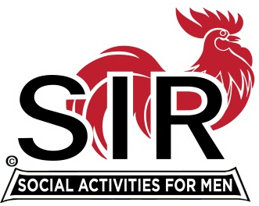
Las Trampas Branch 116
Meeting Agenda
January 18, 2021, 11:30 AM
The Mission of SIR is to enhance the lives of our members through fun activities, events and luncheons – while making friends for life

11:30 Social Time Breakout Rooms

12:00 BIG SIR: Welcome

12:05 Video

12:10 BIG SIR BIG Sir Report
a- “State of the Branch”
b- State SIR Fireside Chat
c- Vaccination update

12:15 Speaker: Speaker Introduction [Fred?]

1:00 Little SIR: “Thanks.” to the Speaker

1:05 BIG SIR: Activities Update [Mike Ward, Fred, Bernie]

1:15 Little SIR: Birthday Boys

1:20 Big SIR: Close Meeting

