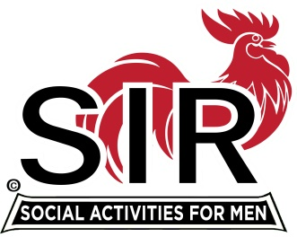**Las Trampas Branch 116**

**Meeting Agenda**

**May 17, 2021, 11:30 AM**

***The Mission of SIR is to enhance the lives of our members through fun activities, events and luncheons – while making friends for life***

**11:30 am Social Time Breakout Rooms**

**12:00 pm BIG SIR: Welcome and BIG SIR report**

**a- State SIR Covid Directives**

**b- Opening Branch Activities**

**c- Branch news**

**12:10 BIG SIR: Activities Update [Mike Ward, Jim Barstow]**

**12:15 Little SIR Speaker Introduction**

**12:20 Speaker De La Salle’s varsity football coach, Justin Alumbaugh**

**12:55 Little SIR Thank Speaker and announce lucky Birthday Boy**

**13:00 BIG SIR Closing Remarks**

*********************************************************************************

**Las Trampas Br. 116 Luncheon Meeting  
Join Zoom Meeting on May 17, 2021 at 11:30 AM**  
<https://us02web.zoom.us/j/89235130696?pwd=a0lXZEhmRzZ2TkJkaEZqN0lSU0pxUT09>  
Meeting ID: 892 3513 0696  
Passcode: 603646  
Dial-in: (669) 900-6833