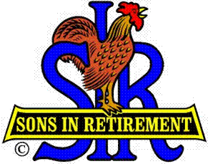**Las Trampas Branch 116**

**Luncheon Meeting Agenda**

**October 21, 2024, 11:30 AM**

**10:30** Social Hour

Greeters – Paul Ramacciotti, Joe Datzman

Treasurer Table – Charlie Guthrie, Al Satake

Name Tags Table – Dennis Snarr

Raffle Table – Ben Bryce, Bob Huck

**11:25**  Five Minute Call

**11:30** Call to order – Big SIR

Pledge of Allegiance – Big SIR

Invocation/Remembrance – Dave Williams

**11:35** Storyteller – Mac McLoughlin

**11:40** Big SIR Report – Alan Pope

Introduce Guests – Don Campbell, Tony Moraga

Welcome Attendance of Speaker – Nik Dehejia

Holiday Party – December 17, Flyers are on tables

Thanks to Past Big SIRS - **Roger Craig (’23) Fred Wachowicz (’22) Sam Beret (’21) Michael Barrington (’20), Jerry Hicks (’19) Marty Katz (’18) Paul Ramacciotti (’17) Jim Barstow (’16) Bob Donohue (’15) Phil Goff (’14) Neil Schmidt (’12) Ron Armijo (’11) Jed Daniel (’10) Art Donaldson (’08)**

**11:46** Activity Reports - Mike Ward: Reports by certain Activity Chairmen

**12:00** Lunch

**12:25** Introduce Speaker – Little SIR

**12:27** Speaker – Nik Dehejia, CEO of Oakland Zoo

**12:52**  Speaker Thank You – Big SIR

**12:54** Raffle Drawing – Bob Huck, Ben Bryce

Birthday Drawing – Little SIR

**13:00** Sing Happy Birthday – Dave Williams

Sing God Bless America – Dave Williams

**13:04** Adjourn; Next meeting, November 18, 2024