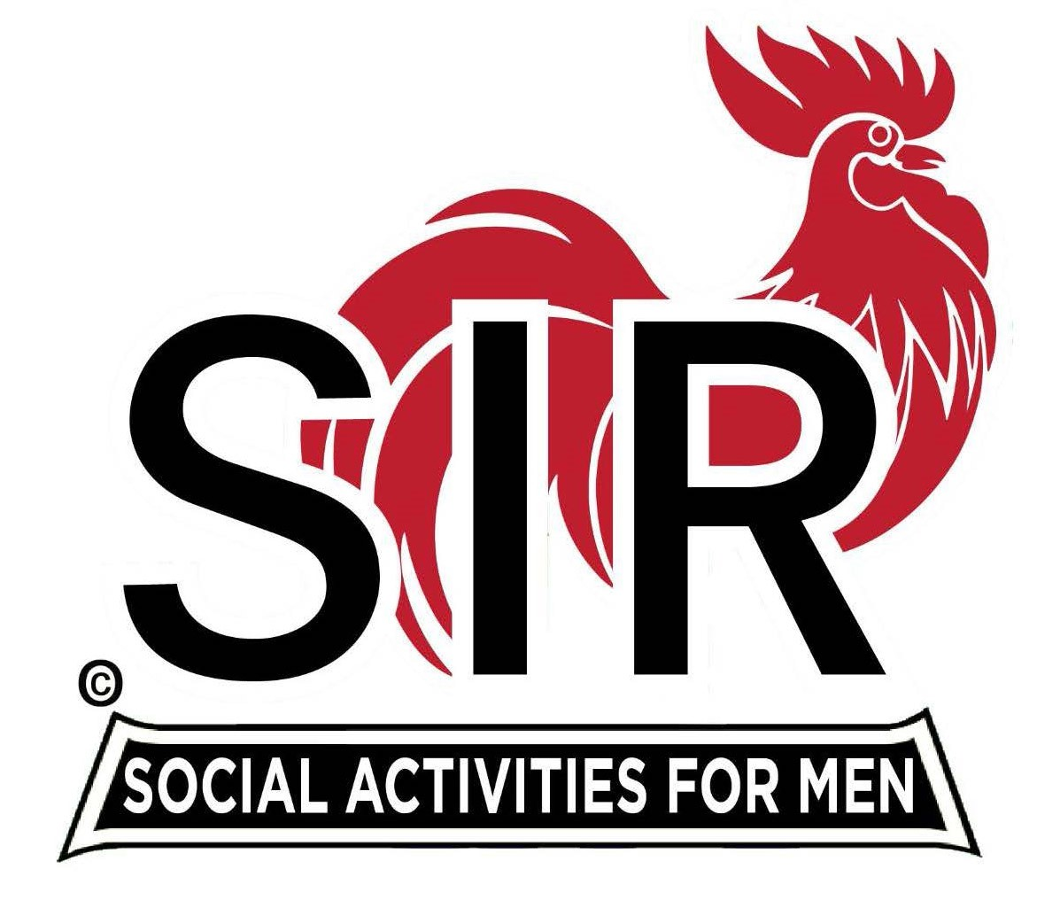
Las Trampas Branch 116
BEC Meeting Agenda
December 29, 10:00 AM
Conference Room, San Ramon Valley United Methodist Church
902 Danville Blvd., Alamo, CA 94507

The Mission of SIR is to enhance the lives of our members through fun activities, events and luncheons while making friends for life.

- Call to Order – Brad Stribling
- Confirm Quorum – Tim Tinnes
- Present November Minutes for Approval – Dan Lawrence
- Business issues – Brad Stribling
  - Introduce meeting and purpose
  - Confirm Nominating & Audit Committee Chairs
  - Clarify 2026 Officers & Directors Installation procedure
  - Update on B.O. luncheon food and cost
- Treasurers Report – Charlie Guthrie
  - Discuss luncheon attendance fees
  - Review and approve 2026 Budget for Branch 116
- New Business
  - Brad – Goals & Actions Development – to present at January BEC
  - Suggestions for filling BEC vacancies?
  - Thoughts on Spring Fling?
  - Other issues…
- Close Meeting

