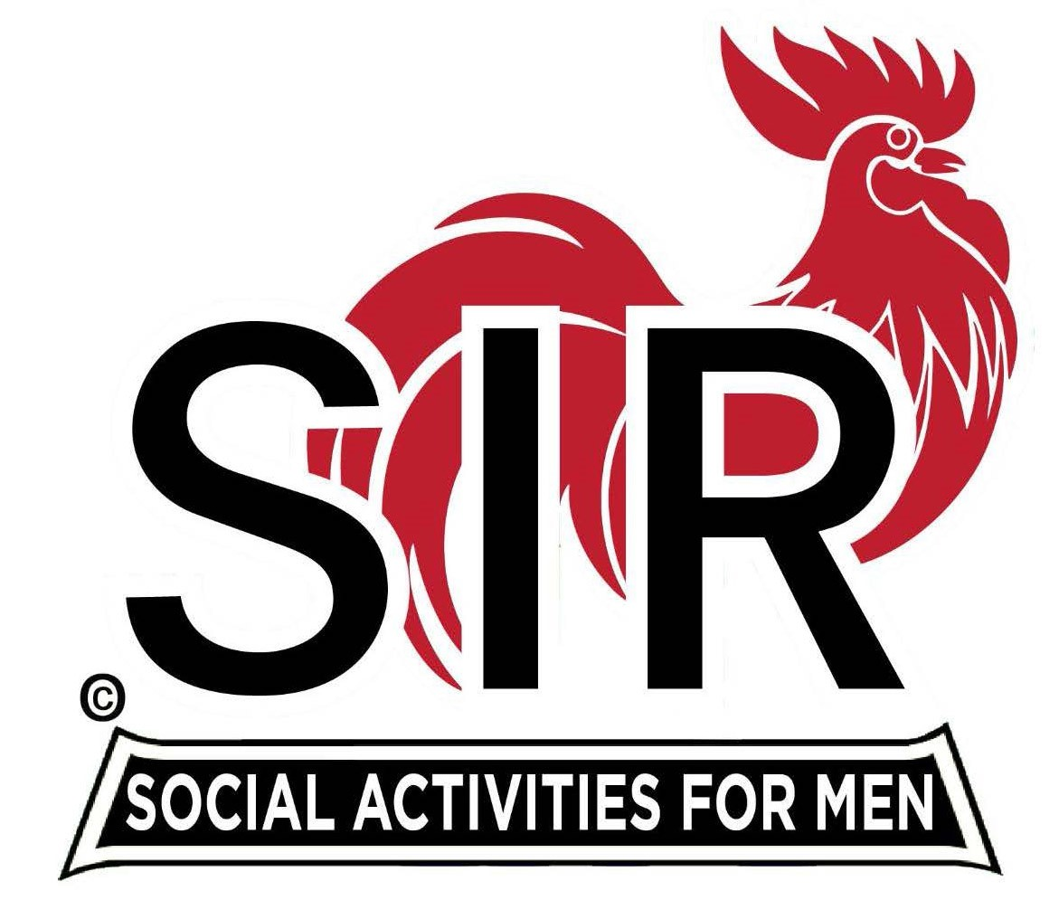

**Las Trampas Branch 116**

**BEC Meeting Agenda**

**February 17th, 2025, 9:15 AM at Boundary Oak**

***The Mission of SIR is to enhance the lives of our members through fun activities, events and luncheons while making friends for life.***

**9:15 am Call to order;**

* **Secretary, Dan Lawrence–**
* **Confirm quorum**
* **Approval of November 18th, 2025 BEC meeting minutes**
* **Approval of January 20th, 2025 BEC meeting minutes**

**9:20 am Standing Reports**

* **Treasurer – Charlie Guthrie** 
  + **Treasury Report**
* **Luncheon Count – ????**
* **Big SIR Report – Paul Russell**
  + **Mix and Mingle during Social Hour**
  + **Let us all try to grow the membership**
  + **Fishbowl Seating ?**
  + **Branch Advisory Council – Carlos Xavier**
* **Membership – Phil Goff**
  + **We will have XX new members?**
* **RAMP Department Head Reports:**
* **Recruitment –Brad Stribling, Jeff Johnson**
  + **New members: ??**
* **Activity Coordinator – Mike Ward**
* **Member Relations - Sam Beret**
* **Publicity – Allan Farbman**
  + **Plans for 2025**
  + **Actions and Goals**
  + **Volunteer Committee Members**

**9:45 am Little SIR Updates – Brad Stribling**

* **Speaker Info – Dan Hanal, BIO**
  + **Birthday Boys – February**

**9:55 am Updates & New Business**

* **New members – Paul Russell** 
  + **???**
* **Greeters – Paul Ramacciatti, Joe Datzman**

**10:15 am Adjourn: Lunch Preparations**