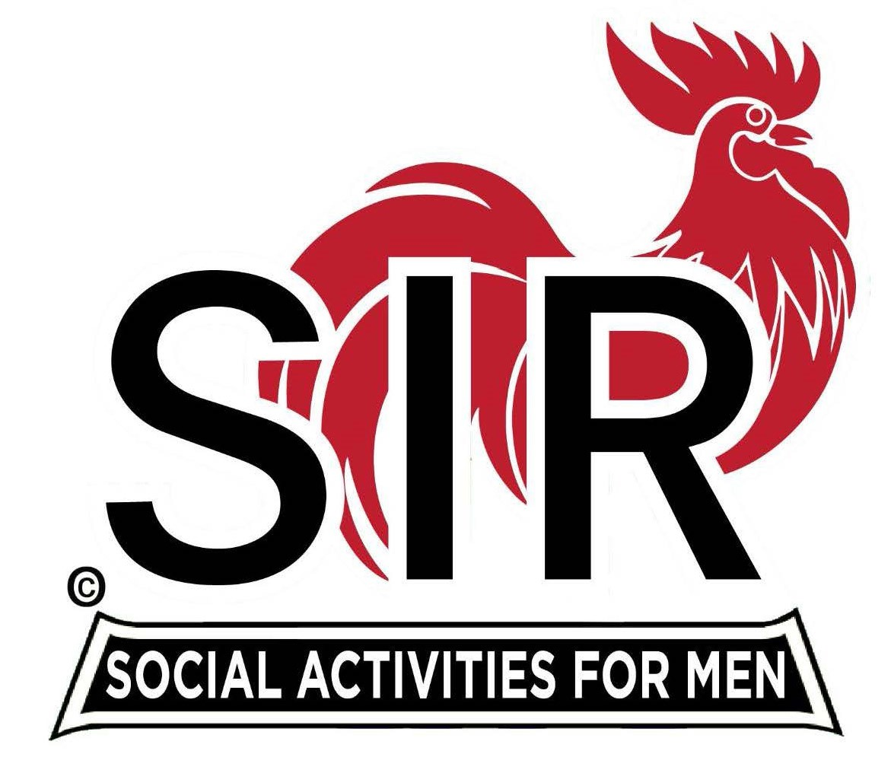

**Las Trampas Branch 116**

**BEC Meeting Agenda**

**January 20th, 2025, 9:15 AM at Boundary Oak**

***The Mission of SIR is to enhance the lives of our members through fun activities, events and luncheons while making friends for life.***

**9:15 am Call to order;**

* **Secretary, Dan Lawrence–**
* **Confirm quorum**
* **Approval of November 18th, 2025 BEC meeting minutes**

**9:20 am Standing Reports**

* **Treasurer – Charlie Guthrie** 
  + **Treasury Report**
* **Luncheon Count – Dennis Snarr**
* **Big SIR Report – Paul Russell**
  + **Branch Advisory Council – Carlos Xavier**
* **Membership – Phil Goff**
  + **We will have 3 New Members**
* **RAMP Department Head Reports:**
* **Recruitment –Brad Stribling, Jeff Johnson**
  + **New members:**
* **Activity Coordinator – Mike Ward**
* **Member Relations - Sam Beret**
* **Publicity – Allan Farbman**
  + **Plans for 2025**

**9:45 am Little SIR Updates – Brad Stribling**

* **Speaker Info – Ed Holloway, BIO**
  + **Birthday Boys – December, 2024**
  + **Birthday Boys – January, 2025**

**9:55 am Updates & New Business**

* **New members – Paul Russell** 
  + **William Trilsh – Richard Black (in December)**
  + **Tom Leahy – Alan Pope for Jim Hemmenway (December)**
  + **Tom Oneto – Alan Pope for Jim Hemmenway (December)**

**Greeters – Paul Ramacciatti, Joe Datzman**

**10:15 am Adjourn: Lunch Preparations**