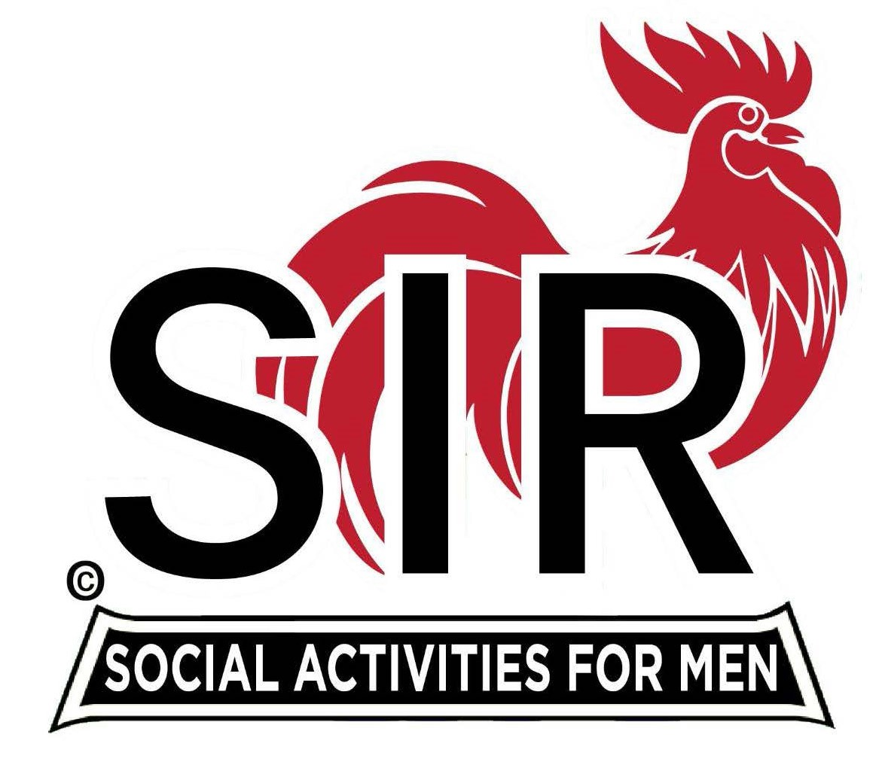

**Las Trampas Branch 116**

**BEC Meeting Agenda**

**March 17th, 2025, 9:15 AM at Boundary Oak**

***The Mission of SIR is to enhance the lives of our members through fun activities, events and luncheons while making friends for life.***

|  |  |
| --- | --- |
| **09:15** | **Call to order**   * **Secretary, Dan Lawrence**    + **Confirm quorum and** * **Approval of February, !7th,2025 BEC Meeting Minutes** |
| **09:20** | **Standing Reports**   * **Treasurer – Charlie Guthrie**   + **Treasury Report** * **Luncheon Count – LCOUNT** * **Big SIR Report – Paul Russel**   + **Branch Advisory Council – Carlos Xavier** * **Membership – Phill Goff**   + **We will have 5 new members?** * **RAMP Department Head Reports**   + **Recruitment – Brad Stribling**   + **Activity Coordinator – Mike Ward**   + **Member Relations – Sam Beret**   + **Publicity – Allan Farbman**     - **Volunteer Committee Members**     - **Announcements** |
| **9:45** | **Little SIR Updates – Brad Stribling**   * **Speaker Info – Mr. Tim Haile, BIO** * **Birthday Boys - March** |
| **9:55** | **Updates & New Business**   * **New Members – Paul Russell**   + **NEW MEMBERS** * **Guests:** * **Sponsors:** * **Greeters – Paul Ramacciatti, Joe Datzman** |
| **10:15** | **Adjourn: Lunch Preparations** |