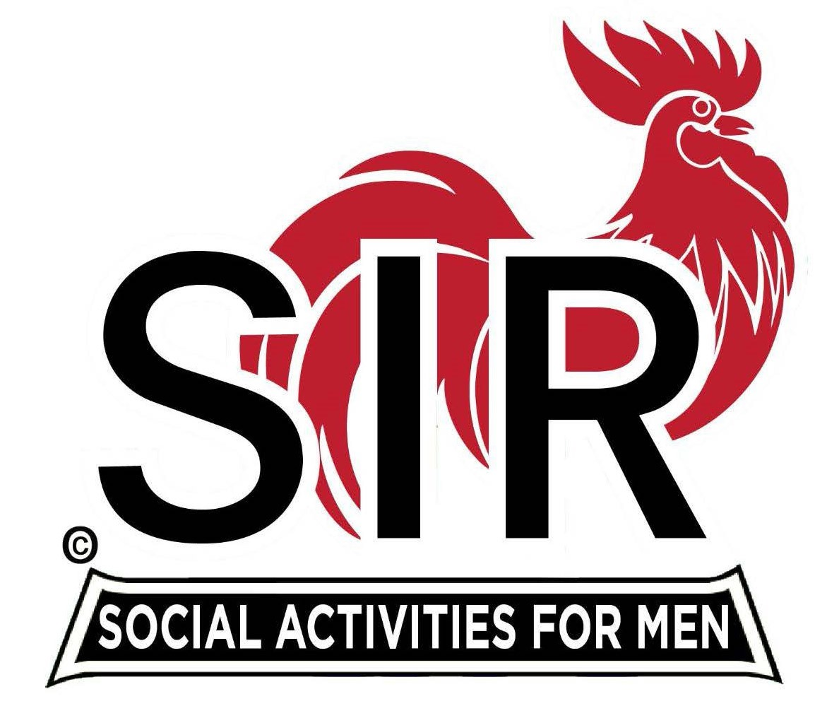
Las Trampas Branch 116
BEC Meeting Agenda
November 17th, - 9:15 AM at Boundary Oak
The Mission of SIR is to enhance the lives of our members through fun activities, events and luncheons while making friends for life.

09:15 | Call to order – Paul Russell  - Secretary - Dan Lawrence  - Confirm quorum  - Approval of October 20th, 2025 BEC Meeting Minutes
09:20 | Standing Reports  - Treasurer Report – Charlie Guthrie  - Treasury Report  - Luncheon Count – Eric Linak  - Big SIR Report – Paul Russell  - New Members:  - Thom Cox – sponsor Rich Black  - Bill Dastic – sponsor Brad Stribling  - Chuck Loughran – sponsor Jerry Kaplan  - Guest:  - Jeff Holloway sponsored by Richard Slaton  - Resignations:  - Resignation – Marsh Stashyn passed away  - Resignation – Bob Colvin passed away  - Membership – Phil Goff  - RAMP Department Head Reports  - Recruitment – Jeff Johnson  - Activity Coordinator – Mike Ward not here  - Member Relations – Sam Beret  - Publicity – Allen Farbman
9:50 | Little SIR Updates – Brad Stribling  - Speaker Info – Mr. Mark Clifford - short Bio  - Birthday Boys – November
9:55 | Updates & New Business  - Please greet our SIR Veterans who have served in the past.  - We would like to keep the price the same for our Holiday Party this year!  - Sign up for the Holiday Party this year!
10:15 | Adjourn: – Next meeting, January 18th, 2026  - Preparations - Lunch

