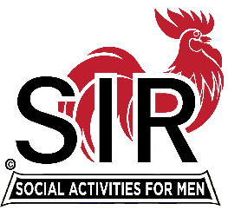**Las Trampas Branch 116**

**Luncheon Meeting Agenda**

**February 17, 2025, 11:30 AM**

**10:30** Social Hour

Greeters – Paul Ramacciatti, Joe Datzman

New Member Orientation – Dave Williams

Treasurer Table – Charlie Guthrie, Al Satake

Name Tags Table – Dennis Snarr, Eric Linak

Raffle Table – Ben Bryce, Bob Huck

**11:25**  Five Minute Call

**11:30** Call to order – Big SIR

Pledge of Allegiance – Big SIR

Invocation/Remembrance – Terry Sherman

* Honorarium – Jon Dickson, Richard Madden

**11:45** Storyteller – Garrett Romain

**11:55** Membership Recruitment / Drive – Brad Stribling

**12:05** Big SIR Report – Paul Russell

Introduce New Member

Introduce Guests

**12:10** Welcome Attendance of Speaker – Dan Hanal

**12:15 Lu**nch

**12:40** Introduce Speaker – Big SIR, Bio

**12:42 Sp**eaker – Dan Hanal

**13.10** Speaker Thank You – Big SIR

**13:15** Raffle Drawing – Bob Huck, Ben Bryce

Birthday Drawing – Little SIR

* February

**13:20** Sing Happy Birthday – Paul King Dave Williams

Sing God Bless America – Paul King, Dave Williams

**13:30** Adjourn; Next meeting, March 17th, 2025