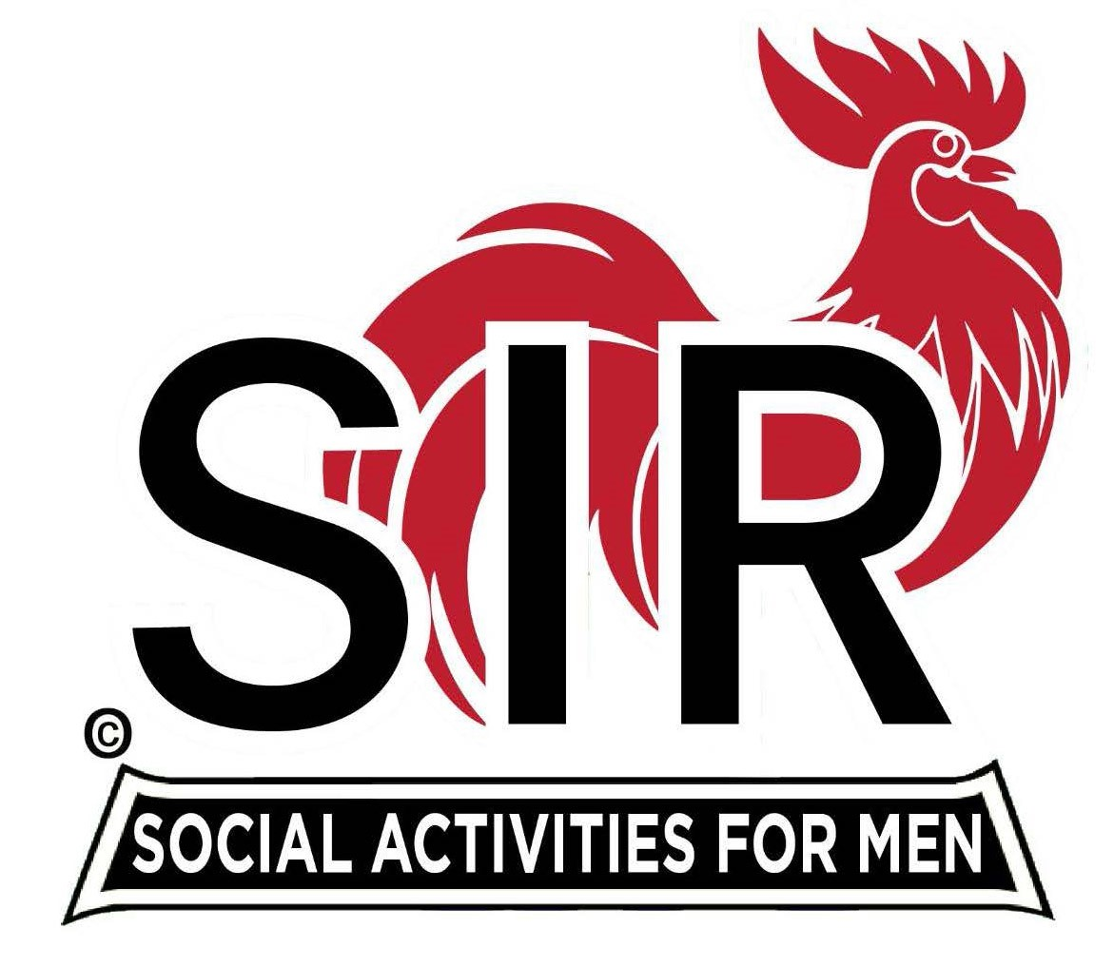
Las Trampas Branch 116
BEC Meeting Agenda - DRAFT
April 20, 2026 - 9:15 AM at Boundary Oak
The Mission of SIR is to enhance the lives of our members through fun activities, events and luncheons while making friends for life.

09:15 | Call to order – Brad Stribling  - Secretary – Jim Grant  - Confirm quorum  - Approval of March 16, 2026 BEC Meeting Minutes
09:20 | Standing Reports  - Treasurer Report – Charlie Guthrie  - Treasury Report  - Luncheon Count – Eric Linak  - Big SIR Report – Brad Stribling  - New Members - see the Luncheon Agenda  - Membership – Phil Goff  - RAMP Department Head Reports  - Recruitment – Jeff Johnson  - Activity Coordinator – still need a nominee ?  - Member Relations – Sam Beret - still need successor  - Publicity – Al Farbman
9:50 | Little SIR Updates – Dan Lawrence  - Speaker Info – Today’s speaker – Lee Culver  - will be introduced at Luncheon by Paul Freitas  - 90 Year Recognitions  - Birthday Boys – April
9:55 | Updates & New Business  - Guests: Guests this month - see Luncheon Agenda  - A Buffet will be tried again - with changes  - Spring Fling - May 19
10:15 | Adjourn: – Next meeting, June 15th, 2026

