SIRS BRANCH 116

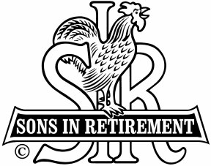

SSS

A Non-Profit Organization for Retired Men Devoted to the Promotion of Independence and Dignity of Retirement

Dear SIR

We all missed you at our July 18, 2016 Meeting.

We look forward to your regular attendance at our monthly meetings. All members have a standing reservation for lunch on the third Monday of each month. If you are unable to attend, you must call SIR 116 Meeting Hot Line at (925) 806-8874 or send an email to snb49@outlook.com by 1:00 p.m., the Thursday before the lunch.

We contract to pay for a set number of lunches and we pay unless you call and tell us you will not be there.

We would appreciate if you would voluntarily send your $15.00 to the Treasurer to reimburse the Branch for the missed lunch. Please make your check payable to SIR Branch 116 and send it to our Treasurer at:

JIM NICKELS
52 BALL ROAD
WALNUT CREEK, 94596 CA

If you think you received this notice in error, please contact our Attendance Chairman, Sam Beret at (925) 388 6145 or email snb49@outlook.com to explain your situation.

Thank you for your assistance and cooperation.

Sincerely,

JIM BARSTOW
BIG SIR
Branch 116

