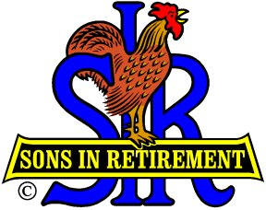

SIR Branch 116 Activities

Please visit our Website at <http://branch116.org> to see details for all of the following activities.

* **Monthly Luncheon** with Guest Speaker (no lunch in May or December)
* **Book Club** – Read and discuss books
* **Book Exchange** – Exchange books at monthly luncheon
* **Bridge** – Meet at Roundhill Country Club twice a month
* **Duplicate Bridge** – Meet at Pleasant Hill Bridge Center once a month
* **Computers & Technology** – Meet at WC Elks Lodge on 3rd Thursday of month
* **Fishing** – Variety of events with monthly meeting at Diablo Creek Golf Course
* **Golf – 18 Hole** – Play golf every Monday at a variety of courses (some private Country Clubs)
* **Golf – 9 Hole** – Play golf every Wednesday at public courses
* **Mexican Train** – Meet on 2nd Wednesday of the month
* **Poker** (small stakes) – Play at Diablo Country Club following SIR luncheon.
* **Finance & Investments** – Hear guest speakers on financial topics. Meet at Diablo Creek Golf course on 4th Wednesday of month.

**Couples Activities**

* + **Amblers** – Short walks and socializing on 2nd & 4th Fridays each month.
  + **Dine Out** – 5 events each year at special restaurants.
  + **Travel** – SIR travel offers opportunities throughout the world to travel with fellow SIR members.
  + **Walking Tours** – Several times a year an interesting venue is offered in the Bay Area.
  + **Wine Appreciation** – Meet in one another’s homes to sample wines and socialize