**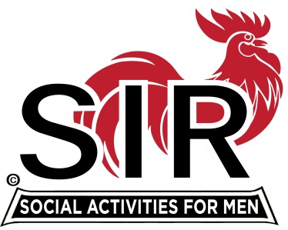 *SONS IN RETIREMENT***

**SIR Las Trampas Branch 116**

**Walnut Creek, CA**

November 23, 2019

Ms. Name of Partner

Street

City, Ca., xxx

Dear xxx (Partner’s First Name)

We are happy to welcome yyyy (first name of inductee) into Branch 116 of Sons in Retirement (SIR). We also wish to extend a warm welcome to you,(name of spouse) as part of our SIR family. Our Branch supports and promotes involvement of our spouses/ significant others. We have many activities for you to take part in. We hope that you too will enjoy the fun and camaraderie that comes with participation with us.

Some of these activities include our very popular Dine-O-SIR group that enjoys the food and drink of local restaurants. We also have a couples Bridge group, Bocce, Pickleball, Wine tasting group, a bay area touring group, and a walking group that generally has coffee and pastries as a reward! Our Travel Group organizes periodic national and international trips. All activities are listed on the Branch 116 WEB site branch116.org and our monthly newsletters.

In May, in celebration of Mother’s Day, we have a Ladies’ Day luncheon. The luncheons are held at local country clubs and include entertainment, door prizes and a great time. Again at Country Clubs, we have a more elegant evening Christmas Dinner Dance with a possible visit, if he isn’t too busy, from Santa Claus. I know that you will enjoy these activities and will meet some very fine couples from our membership.

Monthly, we distribute Trampas Topics, our newsletter that is available to all Members on the SIR Branch 116 Web Site. Trampas Topics provides a summary of events that have been and will be conducted by various Activities and contains information about the Branch. I’m sure that you will want to receive the newsletter, so please make sure that we have your email address.

We know from past history that the SIR experience will be enjoyable as you make new or renew old friendships. We look forward to seeing both of you at SIR events.

Should you have any questions or comments, I welcome emails and/or phone calls.

We are happy to have you join us,

Jerry Hicks

Jerry Hicks

Big SIR (our name for president)

Cell: 925-360-0447

Email: [jerryhicks@astound.net](mailto:jerryhicks@astound.net)