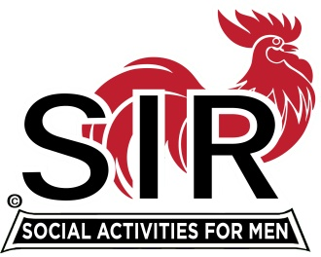**SONS IN RETIREMENT**

**Las Trampas Branch 116**

**Walnut Creek, California**

***The Mission of SIR is to enhance the lives of our members through fun activities and events – while making friends for life.***

November 23, 2019

Dear SIR (Name),

***SIRs*** cordially welcomes you to membership in Branch 116.

We offer opportunities for you to stay active and form friendships through our diverse 19 activity groups. Members find these, from golf to reading and card playing, enjoyable and rewarding. Find information about Branch activities at our website, www.branch116.org.

On your application you indicated interest in a number of our current activities. We have forwarded that information to the chairmen of those activity groups and asked that they contact you to invite you to participate. You too should reach out and try several activities.

Each member of our Branch is assigned a badge number which will appear on your printed badge that you pick up when you pay for your lunch. Picking up the badge will confirm your attendance at the meeting. Your badge number is **(xxx)**.

We look forward to your attending as many lunch meetings as possible each year. The meetings are held on the 3rd Monday of each month at Boundary Oak Golf Course at 11:30 AM. Many members come earlier to socialize before the luncheon. There is no meeting in May or December as we have social events which include our spouses or significant others. Of the ten annual lunch meetings we ask that you attend at least five.

If you are unable to attend a lunch meeting it is imperative that you telephone our hotline at 925-806-8874 or better yet send an email to our attendance chairman at [luncheon116@gmail.com](mailto:luncheon116@gmail.com). Please try to notify him as early as possible since Boundary Oak needs a headcount several days before the meeting. Those members that do not give sufficient notification of their absence will be sent a letter asking them to pay for the missed lunch, as that is not a cost that should be passed on to our membership.

I hope that you enjoy Sons in Retirement as much as I have. Please make an effort to participate in as many of our activities as you wish; they are the primary source of enjoyment. If you have a particular interest which is not currently offered by the Branch, contact our Activities Coordinator, Fred Wachowicz, about starting a new activity group. Also consider volunteering to serve as an Officer or on one of our several support committees. Last, you are always welcome to attend our Executive Committee meetings which start at 9:30 AM on the day of the luncheon in a room across from the main meeting room at Boundary Oak.

Welcome to SIRs Branch 116. Participate and enjoy!

**Jerry Hicks**

Jerry Hicks, Big SIR

[jerryhicks@astound.net](mailto:jerryhicks@astound.net)