In Memory
Sons in Retirement Branch 116 wishes to express our deepest sorrow in the passing of:
“----------“
“-“ was more than just a member of SIR. He was a friend to all and an active participant in many our activities.
“-“ will be greatly missed.

“name of Big SIR” 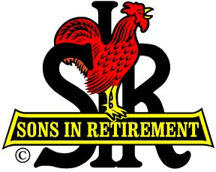
2014 Big SIR, Branch 116

